**BUDDHA SENSOR**

**Electrical Setup**

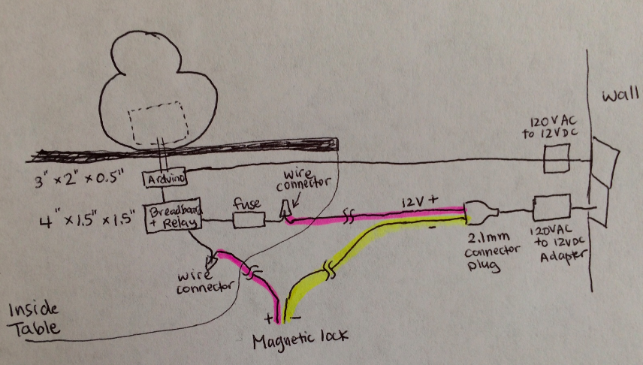

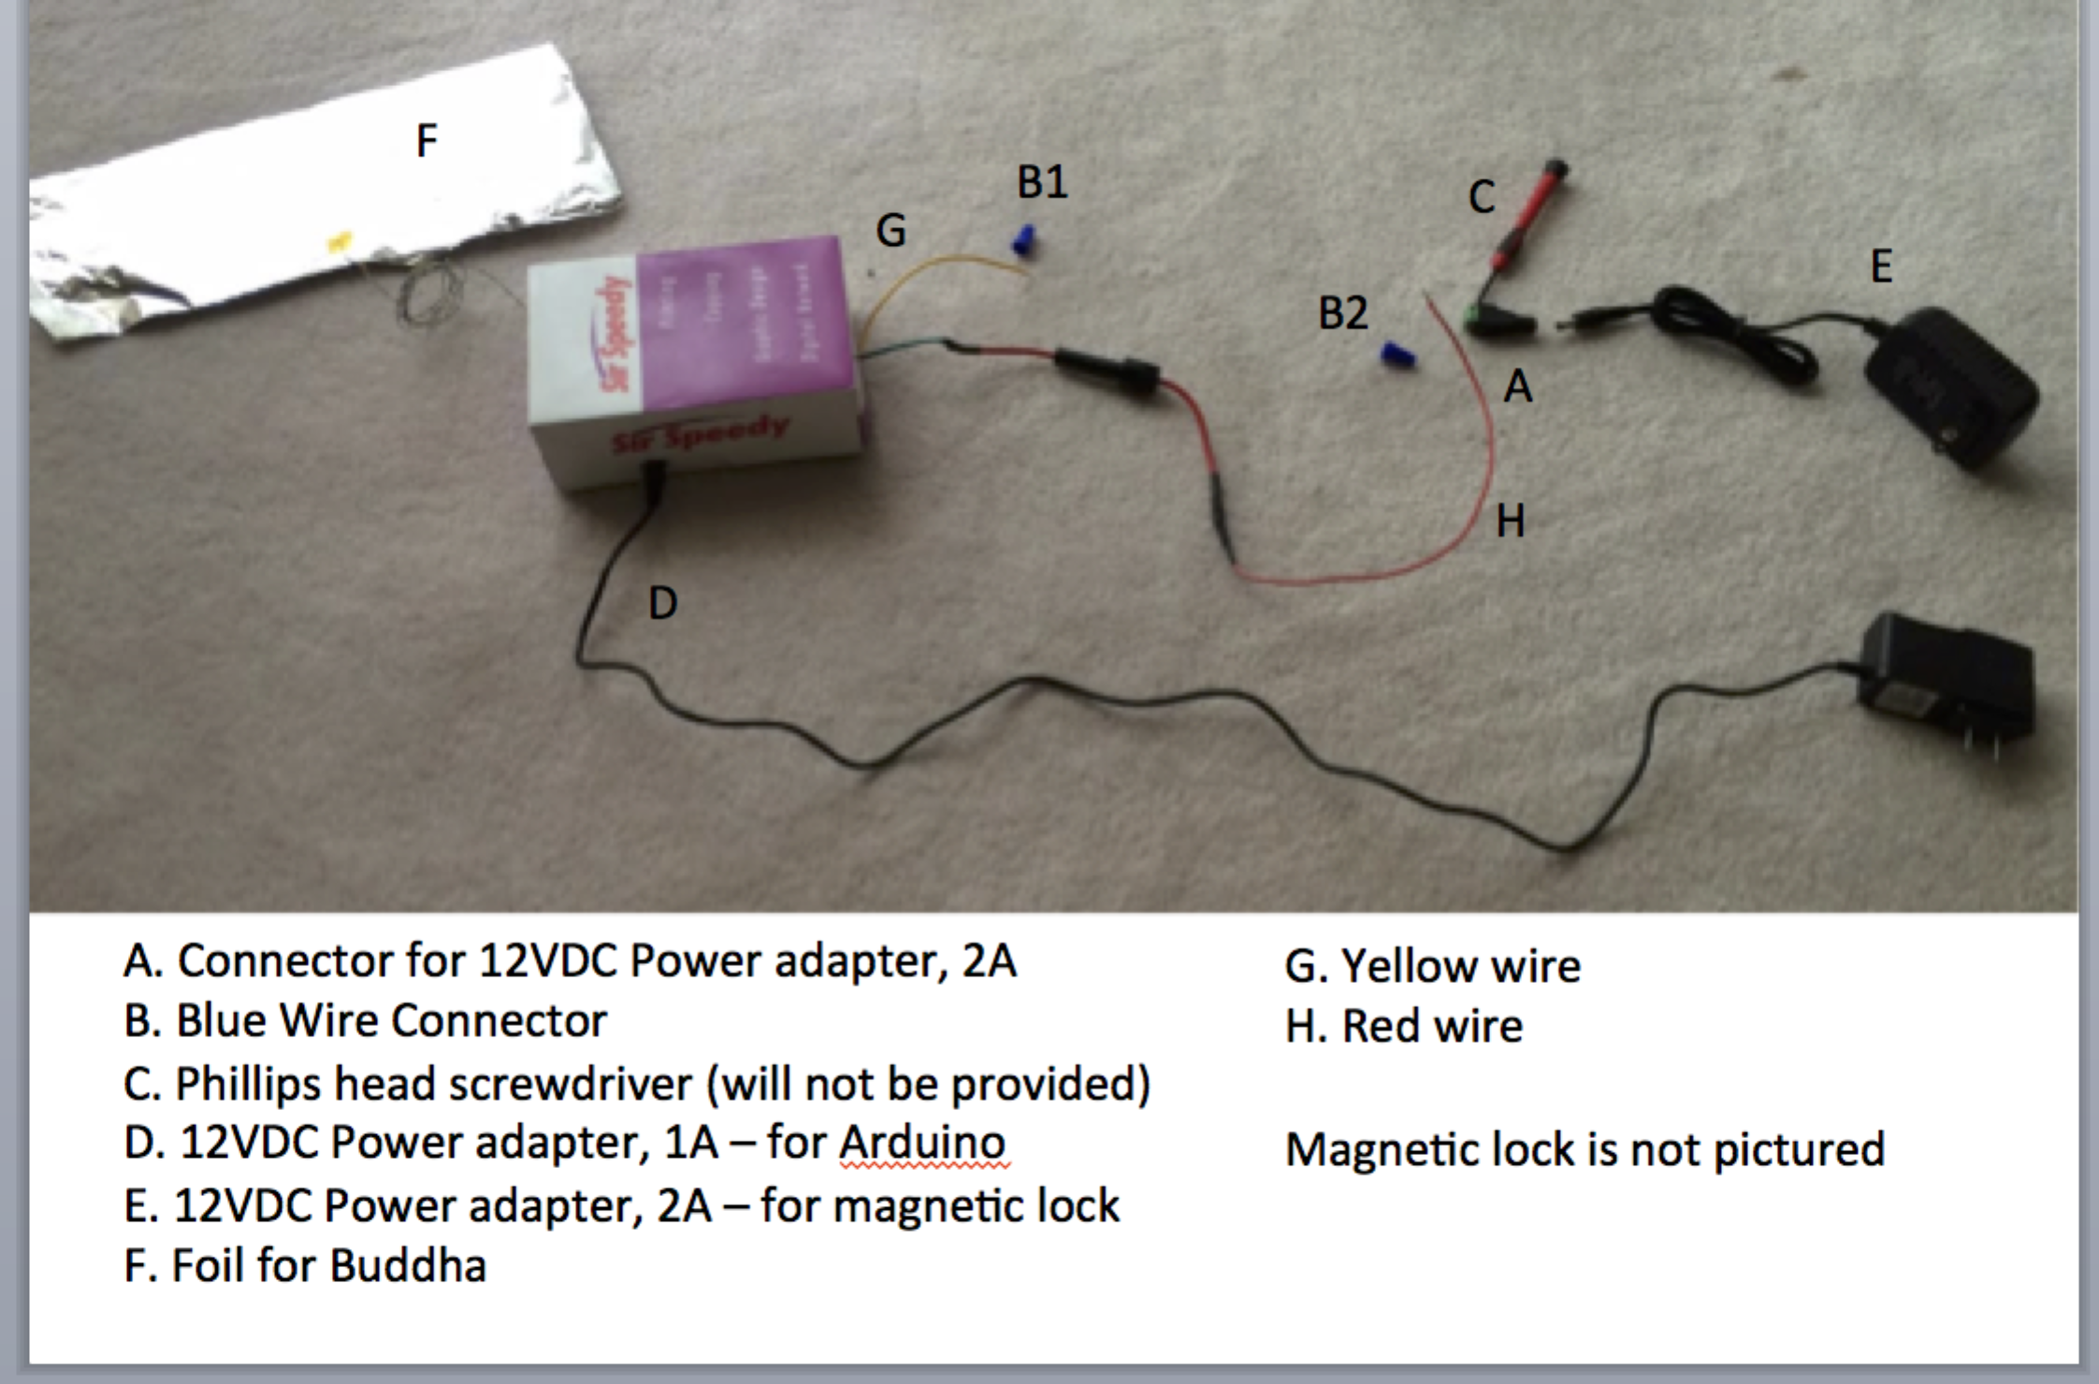

1. Connect power into the Arduino (D). Don’t plug into the outlet yet.
2. Connect wires to your 12VDC magnetic lock
   1. Use the blue wire connector (B1) and connect another wire to the yellow wire (G).
      1. Instructions on how to connect a wire: <http://www.familyhandyman.com/electrical/wiring/how-to-make-safe-wire-connections/view-all>
      2. This new wire should be long enough to reach the magnetic lock.
   2. Screw this new wire into the positive terminal of the magnetic lock
   3. Take a new wire and connect it from the negative terminal of the magnetic lock to the negative terminal (-) of the connector (A). Use a Phillips screwdriver (C)
3. Screw the red wire (H) into the positive terminal (+) of the connector (A). Use a Phillips screwdriver (C).
   1. Optional: If you need to use a longer wire, use the blue wire connector (B2) and connect another wire to the red wire (H). See instructions above on how to connect a wire
4. Connect the connector (A) into the 12VDC magnetic lock power adapter (E). Don’t plug into the outlet yet
5. Attach the foil (F) to the underside of the Buddha belly. Make sure the blue & yellow wire is securely taped/soldered to the foil.
6. Check all connections are secure
7. Plug the Magnetic power adapter (E) into an outlet
8. Plug the Arduino power adapter (D) into an outlet

**Software code**

1. Once you plug in the Arduino power adapter (D), there is a 10sec initialization period. The device is getting an average baseline reading at the blue & yellow wire/foil/Buddha belly. Do not touch the blue & yellow wire/foil/Buddha belly during this initialization period.
   1. The magnetic lock should be locked. 12V should be going through the relay
2. Touch the blue & yellow wire/foil/Buddha belly for 10 seconds or longer. The magnetic lock will be unlocked.
3. Touch the blue & yellow wire/foil/Buddha belly for <10seconds and the magnetic lock will lock

**Inside the box**

Dimensions: 6 inches x 4 inches x 2 inches

